**Exercise 1: Spring Data JPA – Quick Example**

**Implementation:**

**PROJECT STRUCTURE:**

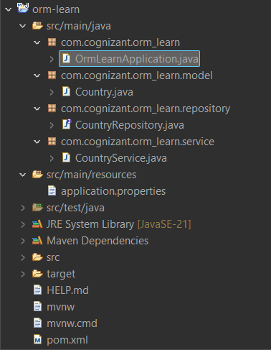

**CODE:**

**pom.xml:**

<?xml version="1.0" encoding="UTF-8"?>

<project xmlns="http://maven.apache.org/POM/4.0.0" xmlns:xsi="http://www.w3.org/2001/XMLSchema-instance"

xsi:schemaLocation="http://maven.apache.org/POM/4.0.0 https://maven.apache.org/xsd/maven-4.0.0.xsd">

<modelVersion>4.0.0</modelVersion>

<parent>

<groupId>org.springframework.boot</groupId>

<artifactId>spring-boot-starter-parent</artifactId>

<version>3.5.3</version>

<relativePath/> <!-- lookup parent from repository -->

</parent>

<groupId>com.cognizant</groupId>

<artifactId>orm-learn</artifactId>

<version>0.0.1-SNAPSHOT</version>

<name>orm-learn</name>

<description>Demo project for Spring Data JPA and Hibernate</description>

<url/>

<licenses>

<license/>

</licenses>

<developers>

<developer/>

</developers>

<scm>

<connection/>

<developerConnection/>

<tag/>

<url/>

</scm>

<properties>

<java.version>21</java.version>

</properties>

<dependencies>

<dependency>

<groupId>org.springframework.boot</groupId>

<artifactId>spring-boot-starter-data-jpa</artifactId>

</dependency>

<dependency>

<groupId>org.springframework.boot</groupId>

<artifactId>spring-boot-devtools</artifactId>

<scope>runtime</scope>

<optional>true</optional>

</dependency>

<dependency>

<groupId>com.mysql</groupId>

<artifactId>mysql-connector-j</artifactId>

<scope>runtime</scope>

</dependency>

<dependency>

<groupId>org.springframework.boot</groupId>

<artifactId>spring-boot-starter-test</artifactId>

<scope>test</scope>

</dependency>

</dependencies>

<build>

<plugins>

<plugin>

<groupId>org.springframework.boot</groupId>

<artifactId>spring-boot-maven-plugin</artifactId>

</plugin>

</plugins>

</build>

</project>

**application.properties:**

# Application name

spring.application.name=orm-learn

# Logging levels

logging.level.org.springframework=info

logging.level.com.cognizant=debug

# Hibernate SQL logging

logging.level.org.hibernate.SQL=trace

logging.level.org.hibernate.type.descriptor.sql=trace

# Log pattern

logging.pattern.console=%d{dd-MM-yy} %d{HH:mm:ss.SSS} %-20.20thread %5p %-25.25logger{25} %25M %4L %m%n

# Database configuration

spring.datasource.driver-class-name=com.mysql.cj.jdbc.Driver

spring.datasource.url=jdbc:mysql://localhost:3306/ormlearn?serverTimezone=UTC

spring.datasource.username=root

spring.datasource.password=root

# Hibernate configuration for MySQL 8+

spring.jpa.hibernate.ddl-auto=validate

spring.jpa.properties.hibernate.dialect=org.hibernate.dialect.MySQLDialect

# Show SQL in stdout (optional but useful)

spring.jpa.show-sql=true

spring.jpa.properties.hibernate.format_sql=true

spring.datasource.url=jdbc:mysql://localhost:3306/ormlearn

spring.datasource.username=root

spring.datasource.password=pswd

**Country.java:**

package com.cognizant.orm_learn.model;

import jakarta.persistence.*;

*@Entity*

*@Table*(name = "country")

public class Country {

*@Id*

*@Column*(name = "co_code")

private String code;

*@Column*(name = "co_name")

private String name;

public String getCode() {

return code;

}

public void setCode(String code) {

this.code = code;

}

public String getName() {

return name;

}

public void setName(String name) {

this.name = name;

}

*@Override*

public String toString() {

return "Country [code=" + code + ", name=" + name + "]";

}

}

**CountryRepository.java:**

package com.cognizant.orm_learn.repository;

import org.springframework.data.jpa.repository.JpaRepository;

import org.springframework.stereotype.Repository;

import com.cognizant.orm_learn.model.Country;

*@Repository*

public interface CountryRepository extends JpaRepository<Country, String> {

}

**CountryService.java:**

package com.cognizant.orm_learn.service;

import java.util.List;

import org.springframework.beans.factory.annotation.Autowired;

import org.springframework.stereotype.Service;

import com.cognizant.orm_learn.model.Country;

import com.cognizant.orm_learn.repository.CountryRepository;

import jakarta.transaction.Transactional;

*@Service*

public class CountryService {

*@Autowired*

private CountryRepository countryRepository;

*@Transactional*

public List<Country> getAllCountries() {

return countryRepository.findAll();

}

}

**OrmLearnApplication.java:**

package com.cognizant.orm_learn;

import java.util.List;

import org.slf4j.Logger;

import org.slf4j.LoggerFactory;

import org.springframework.boot.SpringApplication;

import org.springframework.boot.autoconfigure.SpringBootApplication;

import org.springframework.context.ApplicationContext;

import com.cognizant.orm_learn.model.Country;

import com.cognizant.orm_learn.service.CountryService;

*@SpringBootApplication*

public class OrmLearnApplication {

private static final Logger *LOGGER* = LoggerFactory.*getLogger*(OrmLearnApplication.class);

private static CountryService *countryService*;

public static void main(String[] args) {

ApplicationContext context = SpringApplication.*run*(OrmLearnApplication.class, args);

*countryService* = context.getBean(CountryService.class);

*testGetAllCountries*();

}

private static void testGetAllCountries() {

*LOGGER*.info("Start");

List<Country> countries = *countryService*.getAllCountries();

*LOGGER*.debug("countries={}", countries);

*LOGGER*.info("End");

}

}

**OUTPUT:**

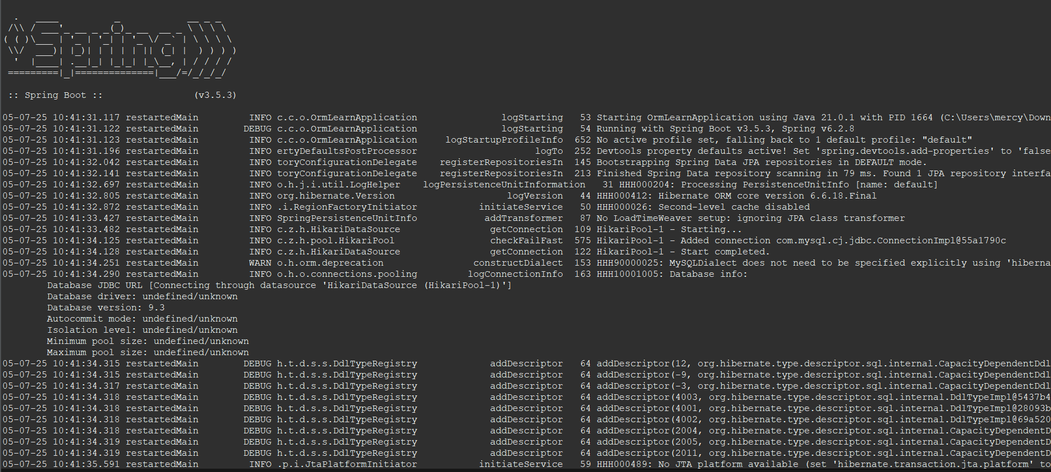

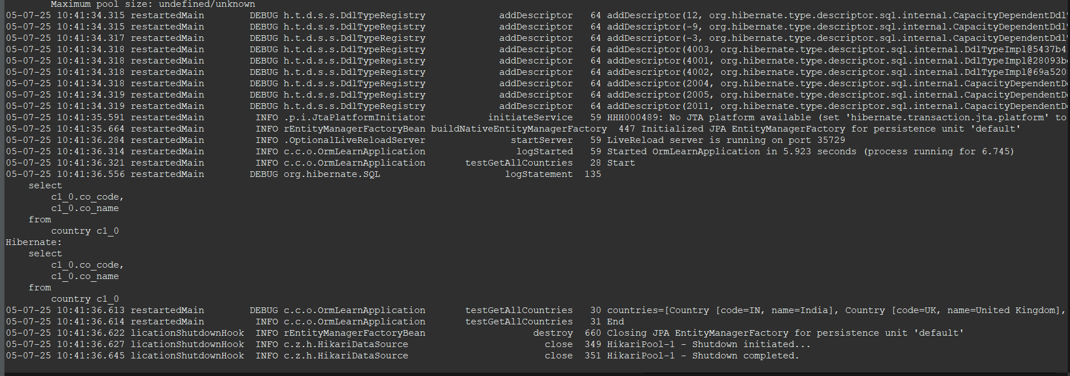

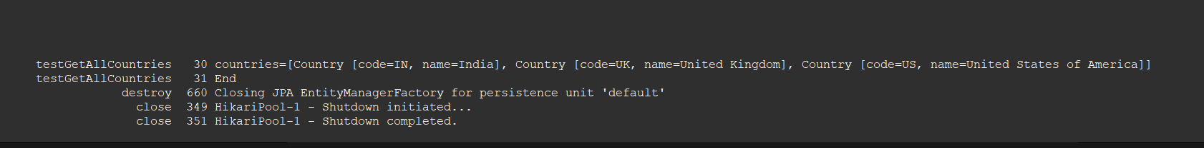

**Exercise 4: Difference between JPA, Hibernate and Spring Data JPA**

**Implementation:**

**PROJECT STRUCTURE:**

**CODE:**